Hurry Up & Be Patient!

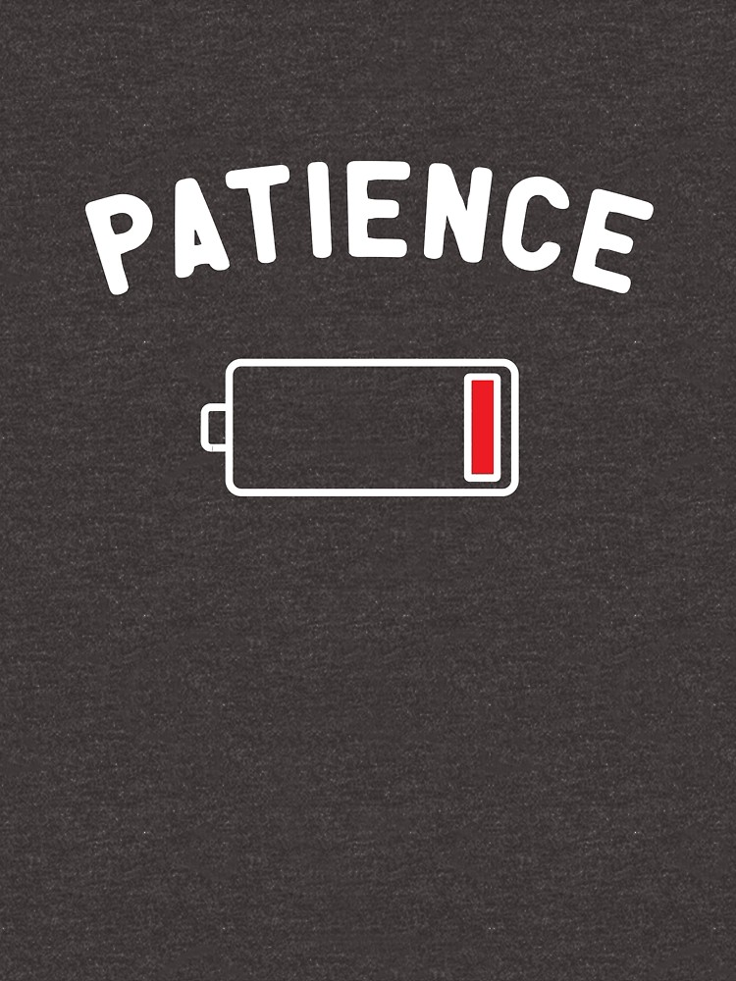

#1
Pirkei Avos 1:1
… Be deliberate (patient and restraint) in judgment ...
Pirkei Avos 2:6
… an impatient one cannot teach ...

Questions:
(a) How long would you wait in a doctor’s office if your appointment was for 1PM and 2:30PM is quickly approaching?
(b) How long do you wait on hold to speak to a customer service representative before hanging up?
(c) How do you feel when stuck in traffic for an hour?
(d) How do you feel when your internet server is too slow?
(e) When is it hardest to wait?
(f) When do you become frustrated?

#2
Heshbon HaNefesh (An Accounting of the Soul)
Woe to the pampered man [or woman] who has never been trained to be patient. Either today or in the future, he is destined to sip from the cup of affliction.

Questions:
(a) Did you ever undertake to learn a new skill – like a foreign language or musical instrument – and then quit?
(b) What was the reason for giving up on acquiring a new skill or continuing a project?

#3
Question: What is the root of impatience?

#4
Talmud Shabbos 88a
A heretic saw Rava engrossed in learning; Rava's fingers were under his leg, he was pressing on them without realizing, they were bleeding.
He said: You are a hasty nation! You put your mouths before your ears, and you persist in your haste! You should have heard the Mitzvos first - then, you can accept if you see that you can keep them!
(The heretic was referring to the impatience of Israel at Mount Sinai when they accepted the Torah unconditionally without waiting to hear all of the details of the Law from G-d.)

Questions:
(a) What are the advantages/disadvantages of being patient?
(b) What are the advantages/disadvantages of being impatient?
(c) Doesn't being patient makes you into a passive, unambitious person?

#5
Midrash Rabbah - Bereishis 3:7
Rabbi Judah son of Rabbi Simon said: "'Let there be evening' is not written here, but 'And there was evening'; hence we know that a time-order existed before this." Rabbi Abahu said: "This proves that the Holy One, blessed be He, went on creating worlds and destroying them until He created this one, and declared, 'This one pleases Me; those did not please Me.'" Rabbi Pinchas said: "This is R. Abahu's reason: 'And God saw everything that He had made, and, behold, it was very good' (Torah Bereishis 1:31). This pleases Me, but those did not please Me.

Question: When can you be objectively sure that it's "not worth it" and it makes sense to not continue a project you started, and it is not a sign of impatience?

#6
Pirkei Avos 6:6
… the Torah is acquired with 48 ways. These are: … #20 slowness to anger ...

Patience is one of the thirteen attributes of G-d listed in the Torah:
Torah, Shmos 34:6
… Lord, Lord, benevolent G-d, Who is compassionate and gracious, patient (slow to anger) and abundant in loving kindness and truth.

The word in Torah for patience is Erech Apayim , literally slow to anger.

Questions:
(a) Why is patience described as “slow to anger”? The opposite of patience must be “quick to anger”. Is it the same as impatience?
(b) How can we cultivate patience?

#7
Question: What’s your takeaway from today’s discussion?

